Results on unimproved grasslands only

## Numerical results

We study 71 focal species.

Above critical abundances, we lose on average compared to the null model: -2.04 (+- 0.77) species in mean alpha richness and -25.94 (+- 17.98) species in total gamma richness

# Table 1

## species th.CI prevalence n.plot.impact th.CI.SRali  
## ACHMIL Achillea_millefolium 2 251 184 NA  
## CRIMUR Critesion_murinum 3 125 21 NA  
## PHLPRA Phleum_pratense 3 54 12 NA  
## TRIREP Trifolium_repens 3 730 605 NA  
## CYNCRI Cynosurus_cristatus 4 601 182 NA  
## DACGLO Dactylis_glomerata 4 677 96 5  
## LOLPER Lolium_perenne 4 735 238 NA  
## RYTRAC Rytidosperma_racemosum 4 131 38 NA  
## TRISTT Trifolium_striatum 4 225 27 NA  
## HOLLAN Holcus_lanatus 5 676 72 4  
## ANTODO Anthoxanthum_odoratum 6 653 12 NA  
## th aRc.old aRo.old aRo aRc aRo.sd aRc.sd aRnull  
## ACHMIL 2 2.464286 4.913043 4.119403 2.364130 3.382318 3.101739 2.828647  
## CRIMUR 3 2.111111 4.163636 3.586538 1.571429 3.151854 2.481359 3.274571  
## PHLPRA 3 1.000000 2.866667 1.928571 1.416667 2.393007 1.831955 1.837833  
## TRIREP 3 6.274419 8.611111 7.136000 4.429752 6.857235 4.690109 4.893860  
## CYNCRI 4 4.408163 6.134328 5.463007 3.664835 5.256615 3.770015 4.917286  
## DACGLO 4 3.531250 5.698529 5.528399 3.166667 5.197941 3.785475 5.186167  
## LOLPER 4 4.351852 6.337500 5.175050 2.731092 4.273835 3.326654 4.374303  
## RYTRAC 4 4.400000 7.321429 6.548387 4.447368 4.621585 2.356100 5.946474  
## TRISTT 4 3.875000 6.038961 5.666667 3.777778 4.272447 2.606697 5.430148  
## HOLLAN 5 4.519231 7.146667 5.274834 3.944444 5.274925 5.208035 5.140667  
## ANTODO 6 2.222222 5.170732 5.552262 2.000000 5.438649 1.651446 5.573417

## aRsdnull alpha.loss aR.P deltaalpha deltaalpha.null  
## ACHMIL 0.13066773 0.4645163 0.0005 -0.28057892 -0.0133277340  
## CRIMUR 0.62535923 1.7031429 0.0005 -0.67049529 0.0339859090  
## PHLPRA 0.58495226 0.4211667 0.2500 -0.56105125 0.0301372801  
## TRIREP 0.08696086 0.4641074 0.0005 -2.16712596 0.0068526047  
## CYNCRI 0.30543507 1.2524505 0.0005 -1.48660033 0.0001006934  
## DACGLO 0.50107171 2.0195000 0.0005 -1.41246533 -0.0061903556  
## LOLPER 0.22626176 1.6432101 0.0005 -0.94718152 -0.0114259128  
## RYTRAC 0.56862432 1.4991053 0.0035 -2.26548442 0.0127379785  
## TRISTT 0.73885219 1.6523704 0.0100 -1.66574995 -0.0093157130  
## HOLLAN 0.57512450 1.1962222 0.0170 -0.06689023 0.0097684145  
## ANTODO 1.50586672 3.5734167 0.0025 -3.78720354 0.0916955697  
## deltaalpha.z.permute.all aR.t aR.df aR.Pt GRo GRc  
## ACHMIL -0.5491642 3.7167112 108.92665 3.204859e-04 70 92  
## CRIMUR -0.9402982 3.2320736 34.44454 2.706845e-03 66 16  
## PHLPRA -0.7858804 0.7936589 22.88077 4.355480e-01 37 14  
## TRIREP -4.3409895 4.2134573 148.84329 4.341188e-05 155 200  
## CYNCRI -3.4207121 4.7379254 470.48931 2.863871e-06 189 94  
## DACGLO -2.4271901 5.3377076 160.85636 3.157536e-07 218 83  
## LOLPER -2.8720575 8.4703411 585.05981 1.982718e-16 174 99  
## RYTRAC -2.8528731 3.4275160 122.76135 8.295312e-04 110 41  
## TRISTT -1.9768458 3.2212178 47.69349 2.301368e-03 112 31  
## HOLLAN -0.1192931 2.0460646 89.26932 4.369213e-02 226 93  
## ANTODO -2.5344167 6.7934708 15.90903 4.447472e-06 240 12  
## GRnull GRsdnull gamma.loss deltagamma delta.z.permute.all  
## ACHMIL 94.168 4.200169 2.168 22 -1.0297041  
## CRIMUR 26.878 5.241430 10.878 -50 -1.7141859  
## PHLPRA 15.380 4.516858 1.380 -23 -0.6027461  
## TRIREP 223.022 6.535766 23.022 45 -3.0499911  
## CYNCRI 129.412 10.523640 35.412 -95 -2.8263864  
## DACGLO 108.877 12.569402 25.877 -135 -1.6329381  
## LOLPER 127.904 7.878379 28.904 -75 -2.8737329  
## RYTRAC 64.120 8.808359 23.120 -69 -2.4080973  
## TRISTT 45.618 8.577392 14.618 -81 -1.4760835  
## HOLLAN 97.658 12.413264 4.658 -133 -0.1786047  
## ANTODO 38.834 11.467342 26.834 -228 -2.2188648  
## delta.null.permute.all GRP.permute.all deltagamma.beta delta.z.beta  
## ACHMIL 32.480 0.1595 22 2.4103951  
## CRIMUR -36.096 0.0230 -50 -3.3996672  
## PHLPRA -18.711 0.2875 -23 -2.4370964  
## TRIREP 102.436 0.0075 45 -0.7080333  
## CYNCRI -45.460 0.0005 -95 -4.8631566  
## DACGLO -107.357 0.0400 -135 -3.8426843  
## LOLPER -36.903 0.0015 -75 -3.2178835  
## RYTRAC -34.098 0.0020 -69 -5.1524682  
## TRISTT -63.205 0.0215 -81 -4.3909835  
## HOLLAN -130.059 0.4590 -133 -2.9179511  
## ANTODO -199.710 0.0020 -228 -6.2619855  
##

delta.null.beta GRP.beta BRo BRc  
## ACHMIL 9.48 0.990 0.9411514 0.9743029  
## CRIMUR -38.53 0.005 0.9456585 0.9017857  
## PHLPRA -17.09 0.005 0.9478764 0.8988095  
## TRIREP 50.23 0.185 0.9539613 0.9778512  
## CYNCRI -51.55 0.005 0.9710952 0.9610124  
## DACGLO -107.61 0.005 0.9746404 0.9618474  
## LOLPER -52.73 0.005 0.9702583 0.9724132  
## RYTRAC -36.99 0.005 0.9404692 0.8915276  
## TRISTT -59.67 0.005 0.9494048 0.8781362  
## HOLLAN -113.41 0.005 0.9766600 0.9575866  
## ANTODO -192.96 0.005 0.9768656 0.8333333

## Figure 1:

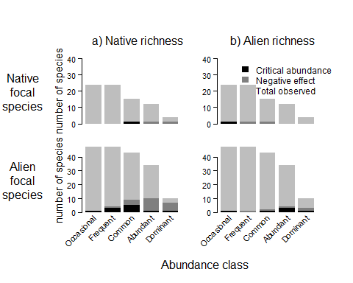

*Frequency of significantly positive or negative coefficients :* 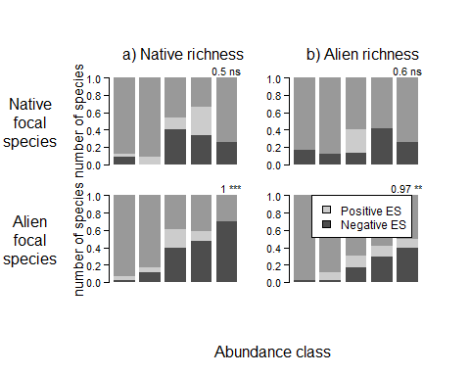

## Figure 2: trends in alpha effect size for 11 species:

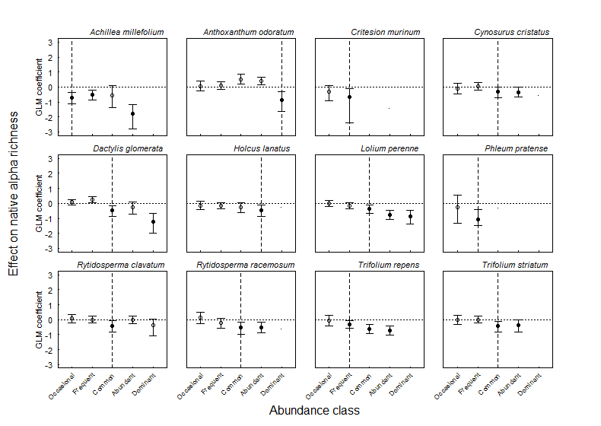

## Figure 3: trends in gamma effect size for 11 species:

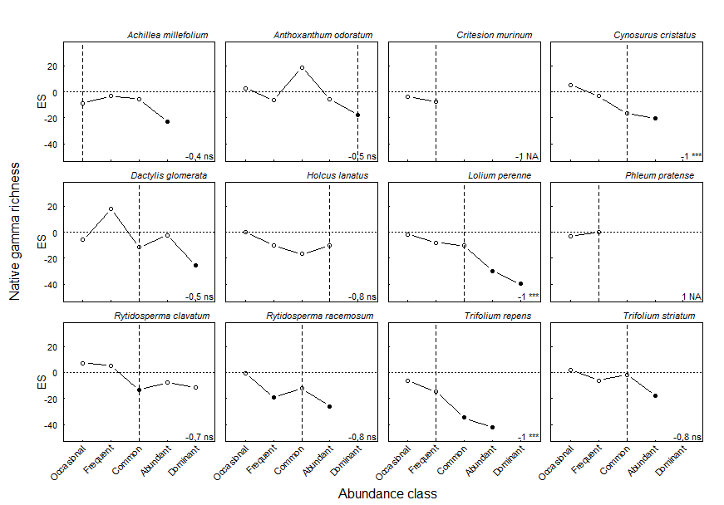

## Figure 4: delta gamma vs. delta alpha:

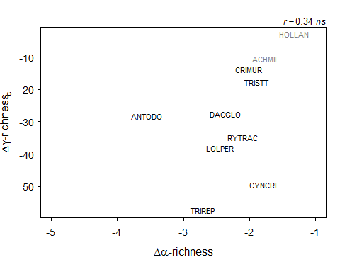

## Figure 5: delta gamma vs. spread: